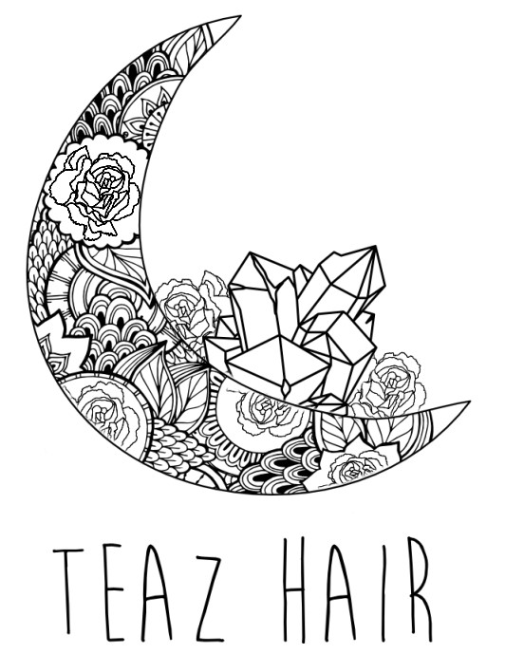
Teaz Hair
Shop 3/30 Guide Street
Jamboree Heights, Brisbane 4074
07 3376 3229 www.facebook.com/Teazhair www.instagram.com/teazhair_/ www.teazhair.com.au

48 HOUR CANCELLATION POLICY
We understand that life gets busy and you may have to cancel or change an appointment with us.
In order to respect the time of both our guests and our staff, we simply ask that you notify us of a cancellation or rescheduling at least 48 hours prior to the appointment. This is so we may have ample time to fill the appointment time should you need to cancel your service. Appointments that are cancelled less than 48 hours prior will result in your deposit being forfeited and a $50 fee charged on your next service.
No Show
In order to respect the time of our Stylists, if an appointment is no showed you will be subject to a $100 no show fee. Please be advised if you NO Show to a correction appointment we will not be able to reschedule the appointment without a 50% deposit.
LATE
Please be courteous to your stylist and other guests. If you are more than 15 minutes late for your appointment, we may have to reschedule as our appointments are scheduled in 15-minute blocks.
DISCLAIMER
A Blow-dry is not included in your colour service unless stated and is a separate service that we highly recommend. Clients who choose not to have a blow-dry and finish the service will not be entitled to any re-do of colour as we have not had the opportunity to see the finished result with you.

